

**Studying in Thailand –**

**Application Requirements and University Information**



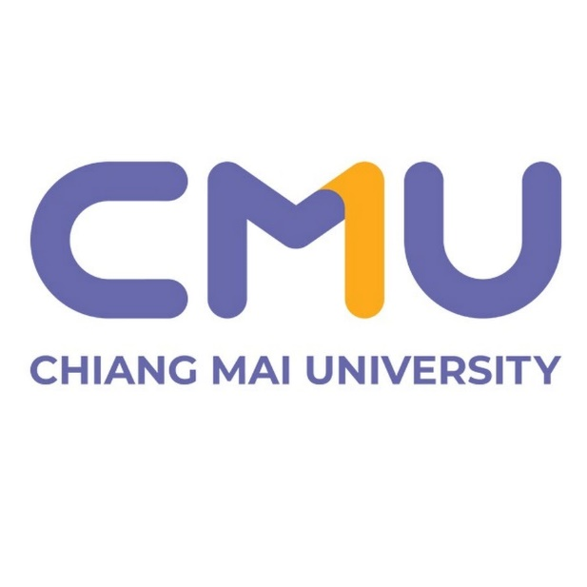

**Chiang Mai University (CMU)**

Chiang Mai University (CMU) is one of Thailand’s top-ranked institutions, located in the culturally rich city of Chiang Mai. CMU offers a variety of programs in English, particularly at the postgraduate level, and is a hub for international students in northern Thailand.

**1. Application Requirements for International Students (Undergraduate and Postgraduate)**

1. **Completed Online Application Form**:
   * Available on CMU’s International College website.
   * You’ll need to create an account to submit your application.
2. **Academic Transcripts**:
   * For undergraduate applicants: High school diploma or equivalent.
   * For postgraduate applicants: Bachelor’s degree transcripts for master’s programs, and master’s degree transcripts for PhD programs.
   * Transcripts must be in English or translated into English/Thai with certified copies.
3. **Degree Certificate**:
   * A copy of your degree certificate (for postgraduate applicants).
4. **English Proficiency Test**:
   * **Undergraduate Programs**:
     + **TOEFL**: Minimum score of 500 (PBT), 173 (CBT), or 61 (iBT).
     + **IELTS**: Minimum score of 5.0.
   * **Postgraduate Programs**:
     + **TOEFL**: Minimum score of 550 (PBT), 213 (CBT), or 79 (iBT).
     + **IELTS**: Minimum score of 6.0.
   * Some programs offer a waiver if your previous studies were conducted in English.
5. **Letters of Recommendation**:
   * **Two letters** for master’s and PhD applicants from academic or professional references.
6. **Statement of Purpose (SOP)**:
   * An essay outlining your academic goals, reasons for applying to CMU, and career aspirations.
7. **Portfolio** (if applicable):
   * Required for creative and design-related programs (e.g., Fine Arts, Architecture).
8. **Resume/CV**:
   * Detailing your academic background and work experience.
9. **Passport Copy**:
   * Must be valid for at least six months from the date of your intended entry to Thailand.
10. **Application Fee**:

* Ranges between **500–1,000 THB** (approximately USD $15–30), depending on the program.

**Deadlines for Chiang Mai University:**

* **For Undergraduate Programs**:
  + Application Deadline for the **First Semester (August)**: **April 30**.
  + Application Deadline for the **Second Semester (January)**: **October 31**.
* **For Postgraduate Programs**:
  + For many programs, the application deadline for the **First Semester (August)** is **March 31**.
  + For the **Second Semester (January)**, the deadline is **September 30**.

**2. Visa Guidance for CMU Students**

The process for obtaining a **Non-Immigrant ED Visa** for CMU is the same as for other Thai universities. Here’s a recap:

**Student Visa (Non-Immigrant ED Visa) Application Process:**

1. **Required Documents**:
   * **Letter of Acceptance**: Official letter from CMU confirming your admission.
   * **Visa Application Form**: Available from your nearest Thai embassy or consulate.
   * **Passport**: Valid for at least six months.
   * **Proof of Financial Support**: Bank statements or a letter from your sponsor showing sufficient funds to cover tuition and living expenses (minimum 20,000 THB per month, or approx. USD $600).
   * **Two Passport-Sized Photographs**.
   * **Visa Fee**: Usually around **2,000–5,000 THB** (USD $60–150), depending on your country of application.
2. **Submit the Application**:
   * Submit your application at your local Thai embassy or consulate. The processing time is typically **5–10 working days**.
3. **Visa Extension**:
   * Once in Thailand, you can extend your visa by visiting the **Chiang Mai Immigration Office**. The extension is typically for one year, but you must apply 30 days before your visa expires.
   * The cost for an extension is **1,900 THB** (USD $60).

**3. Funding Opportunities at Chiang Mai University**

Chiang Mai University offers several scholarships and financial aid programs for international students. Here are some notable options:

**Chiang Mai University Presidential Scholarship**

* **Eligibility**: Open to international students applying for postgraduate studies at CMU.
* **What It Covers**: Full tuition waiver and, in some cases, a stipend for living expenses.
* **Requirements**:
  + Strong academic performance (minimum GPA of 3.5 for master’s applicants and 3.75 for PhD applicants).
  + Proof of English proficiency (TOEFL or IELTS scores).
* **Deadline**: The application deadline is usually **March 31** for the following academic year.

**ASEAN and Non-ASEAN International Scholarships**

* **Eligibility**: Open to students from ASEAN and non-ASEAN countries enrolling in master’s and PhD programs.
* **What It Covers**: Tuition fees, monthly stipend, and travel expenses (for selected students).
* **Deadline**: The application period runs from **March to May** for the August intake.

**Thai Government Scholarships**

* CMU works closely with the **Thailand International Cooperation Agency (TICA)**, offering scholarships for students from developing countries.
* **Covers**: Full tuition, accommodation, and monthly living allowance.
* **Deadline**: Applications usually close in **March** for studies beginning in August.

**4. Key Dates and Deadlines Summary for CMU**

* **Undergraduate Programs**:
  + August Intake: Application deadline is **April 30**.
  + January Intake: Application deadline is **October 31**.
* **Postgraduate Programs**:
  + August Intake: Application deadline is **March 31**.
  + January Intake: Application deadline is **September 30**.
* **Scholarships**:
  + Presidential Scholarship: Apply by **March 31**.
  + ASEAN and Non-ASEAN Scholarships: Apply between **March and May**.
* **Student Visa**:
  + Apply as soon as you receive your acceptance letter. Processing takes **5–10 working days**.
  + You’ll need to extend your visa at the Chiang Mai Immigration Office after the initial 90 days.

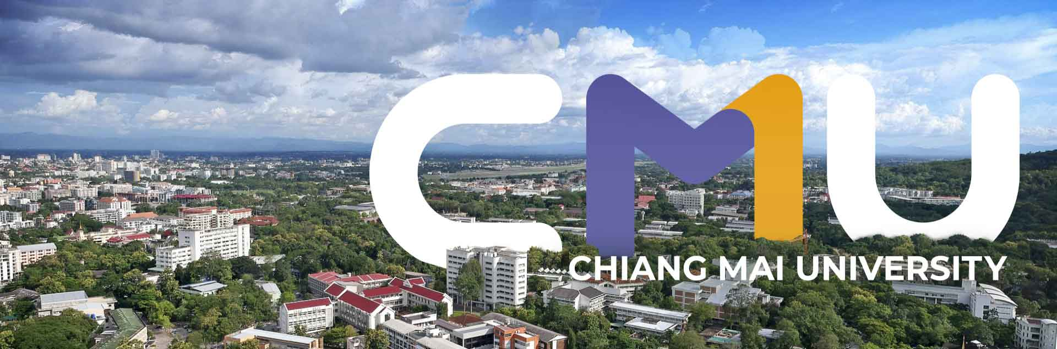

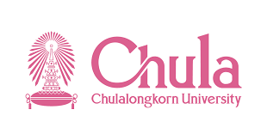

**Chulalongkorn University (CU)**

Chulalongkorn University, located in Bangkok, is one of Thailand's most prestigious and oldest universities. It offers a wide range of undergraduate and postgraduate programs, many of which are taught in English, making it a popular choice for international students.

**1. Application Requirements for International Students (Undergraduate and Postgraduate)**

1. **Completed Online Application Form**:
   * Available through the Chulalongkorn University International Affairs website or the specific faculty's application portal.
   * Register, complete the application, and upload all required documents online.
2. **Academic Transcripts**:
   * For undergraduate applicants: Official high school transcripts or equivalent (e.g., IB, A-Level).
   * For postgraduate applicants: Official bachelor’s degree transcripts for master's programs, and master's degree transcripts for PhD programs.
   * Transcripts must be in English or translated into English/Thai with certified copies.
3. **Degree Certificate**:
   * A copy of your high school diploma for undergraduate applicants.
   * A copy of your bachelor’s degree certificate for master’s applicants.
   * A copy of your master’s degree certificate for PhD applicants.
4. **English Proficiency Test**:
   * **Undergraduate Programs**:
     + **TOEFL**: Minimum score of 500 (PBT), 173 (CBT), or 61 (iBT).
     + **IELTS**: Minimum score of 5.0.
   * **Postgraduate Programs**:
     + **TOEFL**: Minimum score of 550 (PBT), 213 (CBT), or 79 (iBT).
     + **IELTS**: Minimum score of 6.0.
   * Some programs may waive the English test requirement if the applicant’s previous degree was completed in English.
5. **Letters of Recommendation**:
   * **Two letters** for master’s and PhD applicants from academic or professional referees, usually required by postgraduate programs.
6. **Statement of Purpose (SOP)**:
   * A personal essay outlining your academic interests, career goals, and reasons for choosing the specific program at Chulalongkorn University.
7. **Resume/CV**:
   * For postgraduate programs, include an up-to-date CV highlighting your academic and professional background.
8. **Portfolio** (if applicable):
   * Required for creative or design programs, such as in Architecture, Fine Arts, or Media Studies.
9. **Passport Copy**:
   * A scanned copy of your passport, valid for at least six months from the date of intended travel to Thailand.
10. **Application Fee**:
    * Application fees vary by program, but typically range from **500–1,000 THB** (USD $15–30). Payments can often be made online through the application portal.

**Deadlines for Chulalongkorn University:**

* **For Undergraduate Programs**:
  + **August (First Semester) Intake**: Application deadline is **April 30**.
  + **January (Second Semester) Intake**: Application deadline is **October 31**.
* **For Postgraduate Programs**:
  + **August Intake**: Application deadline is **March 31**.
  + **January Intake**: Application deadline is **September 30**.
  + Some specific faculties and programs may have different deadlines, so always check the department's website.

**2. Visa Guidance for Chulalongkorn University**

**Student Visa (Non-Immigrant ED Visa) Application Process**

After receiving your acceptance letter from Chulalongkorn University, you’ll need to apply for a **Non-Immigrant ED Visa** to study in Thailand.

**Required Documents:**

1. **Acceptance Letter**: From Chulalongkorn University, confirming your enrollment.
2. **Visa Application Form**: Available on the Thai embassy/consulate website in your country.
3. **Passport**: Must be valid for at least six months with at least two blank pages.
4. **Proof of Financial Support**: Bank statements or a letter of sponsorship showing a minimum balance of 20,000 THB (USD $600) per month of stay.
5. **Two Passport-Sized Photographs**: Usually 4 x 6 cm, taken within the last six months.
6. **Visa Fee**: Generally, **2,000–5,000 THB** (USD $60–150), depending on your country of application.
7. **Copy of Flight Itinerary**: Not always required but may be requested.

**Visa Application Process:**

1. **Submission**: Submit your application and documents to the Thai embassy or consulate in your home country. Some countries allow online applications, while others may require in-person submissions.
2. **Processing Time**: The visa usually takes **5–10 business days** to process.
3. **Visa Validity**: The initial student visa is valid for 90 days. After arriving in Thailand, you must apply for a visa extension at the **Immigration Bureau** in Bangkok to extend the visa for up to one year.
4. **Visa Extension**:
   * Required documents: Passport, extension application form, proof of student status (from Chulalongkorn University), and financial proof.
   * Cost for extension: **1,900 THB** (approx. USD $60).
   * Extensions are typically granted for one year at a time and need to be renewed annually.

**3. Funding Opportunities at Chulalongkorn University**

**Chulalongkorn University Scholarships for International Students**

Chulalongkorn University offers several scholarships for outstanding international students. These scholarships are either fully funded or partially funded and cover tuition fees, living allowances, and other related costs.

**Chulalongkorn University Graduate Scholarship for ASEAN and Non-ASEAN Countries**

* **Eligibility**: Open to students from both ASEAN and non-ASEAN countries applying for master's and PhD programs.
* **What It Covers**:
  + Full tuition fees.
  + Monthly stipend of **16,000 THB** (approx. USD $480) for living expenses.
  + Round-trip airfare (if applicable).
* **Requirements**:
  + High academic standing (minimum GPA of 3.0 for master’s programs, 3.25 for PhD programs).
  + English proficiency (TOEFL or IELTS).
* **Application Deadline**: For the August intake, the deadline is usually **March 31**. For the January intake, the deadline is **September 30**.
* **How to Apply**: Application must be submitted along with the admission application via the Chulalongkorn University portal.

**Royal Thai Government Scholarships**

* **Eligibility**: Primarily available to students from developing countries, particularly from the ASEAN region.
* **What It Covers**:
  + Full tuition.
  + Living expenses and accommodation.
  + Medical insurance and round-trip airfare.
* **Application Deadline**: Typically, **March 31** for the academic year starting in August.
* **How to Apply**: Apply through your local Thai embassy or via the Thai Ministry of Foreign Affairs.

**Faculty-Specific Scholarships:**

* Certain faculties, such as the **Faculty of Engineering**, **Faculty of Economics**, or the **Faculty of Architecture**, also offer scholarships specific to their disciplines. These scholarships often prioritize academic excellence, leadership skills, and research potential.

**4. Key Dates and Deadlines Summary for Chulalongkorn University**

* **Undergraduate Programs**:
  + **First Semester (August)**: Application deadline is **April 30**.
  + **Second Semester (January)**: Application deadline is **October 31**.
* **Postgraduate Programs**:
  + **August Intake**: Application deadline is **March 31**.
  + **January Intake**: Application deadline is **September 30**.
* **Scholarships**:
  + **Graduate Scholarship for ASEAN and Non-ASEAN Countries**: Apply by **March 31** (for the August intake) or **September 30** (for the January intake).
  + **Royal Thai Government Scholarships**: Apply by **March 31** for the following academic year.
* **Student Visa**:
  + Apply for the Non-Immigrant ED Visa as soon as you receive your acceptance letter. Visa processing usually takes **5–10 working days**.
  + Apply for visa extensions at the Bangkok Immigration Bureau at least 30 days before the 90-day visa period ends.

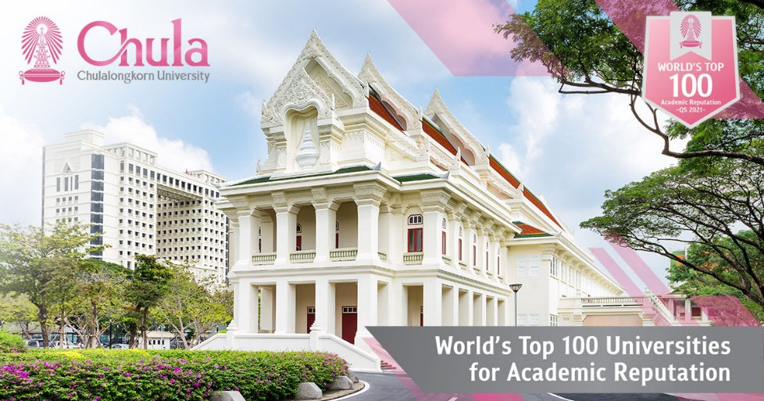

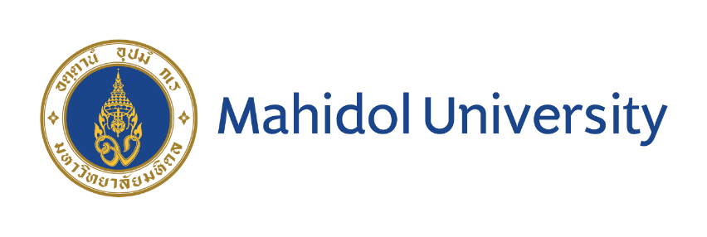

**Mahidol University (MU)**

Mahidol University, located in the suburbs of Bangkok, is one of Thailand’s most prestigious universities. Known for its research programs and a strong focus on health sciences, Mahidol also offers a wide range of programs in fields like business, social sciences, and engineering. Many of these programs are taught in English, making it a prime destination for international students.

**1. Application Requirements for International Students (Undergraduate and Postgraduate)**

1. **Completed Online Application Form**:
   * Available on the Mahidol University International Admissions portal.
   * You must register, complete the form, and upload necessary documents.
2. **Academic Transcripts**:
   * **Undergraduate Applicants**: High school transcripts or equivalent (e.g., IB, A-Level).
   * **Postgraduate Applicants**: Official transcripts from your bachelor’s degree for master’s programs or master’s degree for PhD programs.
   * Transcripts must be in English or certified translations if in another language.
3. **Degree Certificate**:
   * For undergraduate applicants: High school diploma or equivalent.
   * For postgraduate applicants: A copy of your bachelor’s or master’s degree certificate.
4. **English Proficiency Test**:
   * **Undergraduate Programs**:
     + **TOEFL**: Minimum score of 500 (PBT), 173 (CBT), or 61 (iBT).
     + **IELTS**: Minimum score of 5.0.
   * **Postgraduate Programs**:
     + **TOEFL**: Minimum score of 550 (PBT), 213 (CBT), or 79 (iBT).
     + **IELTS**: Minimum score of 6.0.
   * Waivers may be granted if your previous studies were in English or if you come from an English-speaking country.
5. **Letters of Recommendation**:
   * **Two letters** for master’s and PhD applicants from academic or professional referees.
6. **Statement of Purpose (SOP)**:
   * A 1–2-page essay explaining your academic and professional goals, why you wish to study at Mahidol University, and your research interests (for postgraduate applicants).
7. **Resume/CV**:
   * For postgraduate applicants, a detailed resume outlining your academic achievements and relevant work experience.
8. **Portfolio** (if applicable):
   * Required for certain creative or specialized programs, such as those in Fine Arts or Design.
9. **Passport Copy**:
   * A copy of your valid passport, with at least six months of validity from the time of application.
10. **Application Fee**:
    * The application fee ranges between **500–1,000 THB** (USD $15–30), depending on the program.

**Deadlines for Mahidol University:**

* **For Undergraduate Programs**:
  + **August (First Semester) Intake**: Application deadline is typically **April 30**.
  + **January (Second Semester) Intake**: Application deadline is **October 31**.
* **For Postgraduate Programs**:
  + **August Intake**: The deadline is usually **March 31**.
  + **January Intake**: The deadline is **September 30**.
  + **Note**: Different faculties may have varying deadlines, so always check the specific faculty’s website.

**2. Visa Guidance for Mahidol University**

To study at Mahidol University, international students must obtain a **Non-Immigrant ED Visa**, which is specifically for students.

**Required Documents for Visa Application:**

1. **Acceptance Letter**: From Mahidol University, confirming your enrollment.
2. **Visa Application Form**: Available from the Thai embassy or consulate in your home country.
3. **Passport**: Valid for at least six months with at least two blank pages.
4. **Proof of Financial Support**: Bank statements or a sponsorship letter showing sufficient funds (at least 20,000 THB or USD $600 per month).
5. **Two Passport-Sized Photographs**: Recent photos, usually sized 4 x 6 cm.
6. **Visa Fee**: This varies depending on the country but typically ranges between **2,000–5,000 THB** (USD $60–150).
7. **Flight Itinerary** (optional): In some cases, embassies may ask for proof of your travel plans.

**Visa Application Process:**

1. **Submission**: Submit your documents to the Thai embassy or consulate in your home country. Some countries may allow you to submit your application online, while others require in-person submission.
2. **Processing Time**: It typically takes **5–10 working days** for the visa to be processed.
3. **Visa Validity**: The student visa is usually issued for 90 days. After you arrive in Thailand, you’ll need to apply for a one-year visa extension through the Thai Immigration Bureau.
4. **Visa Extension**:
   * Visit the **Immigration Office** before your initial 90-day visa expires.
   * Required documents include proof of enrollment, passport, visa extension application form, and financial proof.
   * The extension costs **1,900 THB** (USD $60), and the process usually takes a few days.

**3. Funding Opportunities at Mahidol University**

Mahidol University offers several scholarships for international students, particularly at the postgraduate level.

**Mahidol University Graduate Scholarships:**

This is one of the most prominent scholarship schemes offered to postgraduate international students.

* **Eligibility**: Open to international students enrolling in master’s and PhD programs.
* **What It Covers**:
  + Full tuition fees.
  + Monthly stipend for living expenses.
  + Accommodation allowance.
  + Health insurance.
* **Requirements**:
  + Excellent academic background (minimum GPA of 3.0 for master’s and 3.25 for PhD applicants).
  + Strong English proficiency (TOEFL or IELTS).
* **Application Deadline**: The deadline is usually **March 31** for the first semester (August intake), and **September 30** for the second semester (January intake).

**Royal Thai Government Scholarships:**

* **Eligibility**: Primarily for students from developing countries in Asia, Africa, and Latin America.
* **What It Covers**:
  + Full tuition fees.
  + Living expenses.
  + Travel expenses (round-trip airfare).
* **Application Deadline**: Usually **March 31** for the following academic year.
* **How to Apply**: Through Mahidol University or the Ministry of Foreign Affairs in your home country.

**Faculty-Specific Scholarships:**

Some faculties, such as the **Faculty of Medicine** or **Faculty of Science**, may offer specific scholarships for students pursuing research or advanced degrees. These scholarships are often merit-based and may require specific academic or research achievements.

**Mahidol Postgraduate Fellowship:**

This fellowship is for outstanding students who wish to pursue research in specific areas. It offers a generous monthly stipend and research support, especially for PhD students.

**4. Key Dates and Deadlines Summary for Mahidol University**

* **Undergraduate Programs**:
  + **August Intake (First Semester)**: Application deadline is usually **April 30**.
  + **January Intake (Second Semester)**: Application deadline is **October 31**.
* **Postgraduate Programs**:
  + **August Intake**: Application deadline is typically **March 31**.
  + **January Intake**: Application deadline is **September 30**.
* **Scholarships**:
  + **Mahidol Graduate Scholarships**: Apply by **March 31** (for the August intake) or **September 30** (for the January intake).
  + **Royal Thai Government Scholarships**: Apply by **March 31**.
* **Student Visa**:
  + Apply for the **Non-Immigrant ED Visa** immediately after receiving your acceptance letter. Visa processing generally takes **5–10 working days**.
  + After arriving in Thailand, extend your visa at the Thai Immigration Bureau within the 90-day visa period.

